Across America, teachers are helping students meet the high expectations of college- and career-ready standards. In the coming school year, new assessments aligned to the Common Core State Standards will give teachers new tools and better information to monitor student progress.

Many parents and community members are just learning about the new standards and assessments being implemented in schools. Teachers play an important role in helping parents and community members understand the changes going on in our classrooms and what they will mean for students.

This toolkit is intended to assist educators in communicating about the Smarter Balanced Assessment System.

TABLE OF CONTENTS
- Information about the assessments, including the timeline for launch
- Talking points about the assessment system and the spring 2014 Field Test
- Common misperceptions about the assessments and facts to set the record straight
- Answers to questions from parents
- Resources for teachers about the assessments, the Common Core, and communicating with parents
- Communication tips for making your voice heard
- Sample questions that illustrate how Smarter Balanced is assessing the Common Core
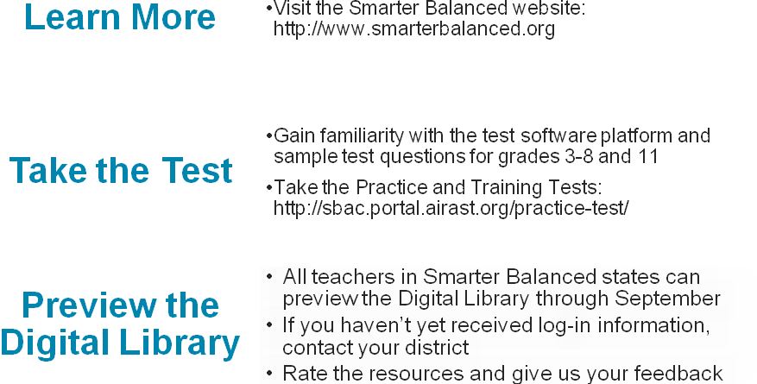

ABOUT THE ASSESSMENTS
States are partnering in the Smarter Balanced Assessment Consortium to develop online assessments aligned to the Common Core. These tests will measure how well students are progressing toward readiness for college and careers. They offer improvements over tests of the past, including: writing at every grade; expanded accessibility features to meet the needs of all students; and performance tasks that ask students to demonstrate an array of research, writing, and problem solving skills.

In addition to measuring student achievement at the end of the school year, the Smarter Balanced Assessment System will provide information during the year to give teachers and parents a better picture of where students are succeeding and where they need help. The assessment system includes three core components:
- Digital Library that includes hundreds of formative assessment resources and practices that teachers can use throughout the year;
- Interim assessments that allow teachers to check in on student progress and provide information to inform instruction; and
- Summative assessments administered during the last 12 weeks of the school year.

Digital Library on Formative Assessment | Available October 2014
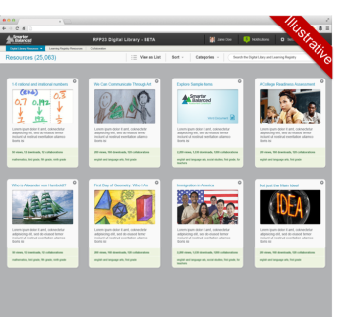 | - The Digital Library is an online collection of resources aligned to the Common Core that will support K-12 teachers’ use of the formative assessment process. It includes:  - Assessment literacy modules  - Exemplar instructional modules  - Education resources submitted and vetted by teachers  - Teachers can rate materials and share their expertise with educators across the country.
Interim Assessments | Available Fall 2014
- Grades 3-8 and high school are supported. At the high school level, the assessments are consistent with the grade 11 summative design and may be administered in grades 9, 10, 11, and/or 12.  - Items were developed under the same conditions, protocols, and review procedures as those used in the summative assessments.  - Test questions are not secure, and there are no restrictions on the number of times that teachers or students may access the assessments.  - Most questions can be scored by the Smarter Balanced Test Delivery Engine. Constructed-response items and performance tasks will be scored by teachers locally. | Two options:  - Interim Comprehensive Assessments use the same design as the summative assessments, assess the same range of standards, and provide scores on the same scale.  - Interim Assessment Blocks focus on smaller sets of related standards and provide more detailed information for instructional purposes.  For more information on the Interim Assessments, including a full list of topics covered by the Interim Assessment Blocks, visit: http://www.smarterbalanced.org.
Summative Assessments | Available Spring 2015
- The Summative Assessments will be administered during the last 12 weeks of the school year for grades 3-8 and 11, providing an accurate and fair measure of student growth and achievement.  - Students will complete a computer adaptive test and performance task in English language arts and math.  - Students will receive composite scores for each subject area and the following claim-level results:  - English language arts-reading, writing, listening, and research;  - Math-concepts and procedures, problem solving and modeling/data analysis, and communicating reasoning. | 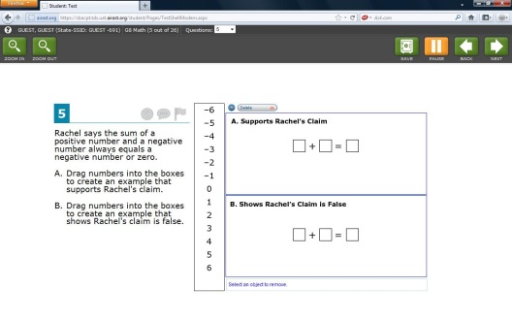
TALKING POINTS
The Smarter Balanced assessments are a key part of implementing the Common Core State Standards and preparing all students for success in college and careers.
- The Common Core State Standards establish consistent academic expectations in English and mathematics for the knowledge and skills students need to succeed in college and careers. More than 40 states have adopted these standards and are working to provide teachers and students the support they need to reach them.
- States are partnering in the Smarter Balanced Assessment Consortium to develop a new assessment system aligned to the Common Core to measure how well students are progressing toward readiness for college and careers.
- The Smarter Balanced Assessment System will replace existing tests and offer significant improvements over tests of the past, including: writing at every grade; expanded accessibility features to meet the needs of all students; and performance tasks that ask students to demonstrate an array of research, writing, and problem solving skills.
- In addition to measuring student achievement at the end of the school year, the Smarter Balanced Assessment System will provide information during the year to give teachers and parents a better picture of where students are succeeding and where they need help. The assessment system features flexible interim assessments that schools and districts can implement to gauge student progress during the year and inform instruction, as well as a Digital Library of teacher-selected resources on classroom-based formative assessments.
- The work of Smarter Balanced is guided by the belief that a high-quality assessment system can provide information and tools for teachers and schools to improve instruction and help all students succeed—regardless of disability, language, or background. The assessment system include a wide array of accessibility tools for all students and accommodations—such as Braille—for those who need them.
A Field Test of the Smarter Balanced Assessment System took place from March 25 through June 13, culminating a three-year, multi-stage research and development process to ensure these assessments work properly.
- More than four million students participated in the Field Test across 21 states.
- This practice run helped to ensure that the assessments are accurate and fair for all students. It also gave teachers and schools a chance to practice test administration procedures, and students the opportunity to experience the new assessments.
- Field testing is about “testing the test” itself—there will be no results shared with students, schools or districts, so there will not be any consequences for teachers or students.

Smarter Balanced states have worked closely with administrators, teachers, and students for more than two years to ensure a smooth roll-out of the new assessments, and to make sure schools and teachers have the right supports in place.
- For the past two years, Smarter Balanced has worked directly with teachers and students across the country—through labs, discussions, the development of more than 20,000 test questions, and a preliminary Pilot Test last year—to ensure that the assessments accurately measure the full breadth and depth of the Common Core.
- We didn’t expect this practice run to be perfect, and we expected to discover challenges. Working together with teachers and school administrators, states in the Smarter Balanced Assessment Consortium will address any issues identified prior to the launch of the assessment system in the 2014–15 school year.
COMMON MISCONCEPTIONS
There has been a lot of coverage of the Common Core and the Smarter Balanced assessments in the news and a lot of information—and misinformation—circulated online. Parents and other stakeholders may have questions about the changes underway to prepare students for college and the workplace. Whatever your opinion about the new standards and assessments, it’s important to have the facts. Below are common misperceptions about Smarter Balanced, along with explanations and links to additional resources.

Fiction: These tests represent a new federal intrusion into education
Fact: For decades Congress has required assessments of student learning for accountability under the Elementary and Secondary Education Act (ESEA). The 2001 reauthorization of ESEA, known as the “No Child Left Behind Act” enacted during the Bush Administration, expanded those federal testing requirements to include state testing of every student in language arts and mathematics in grades 3 through 8 and once in high school. In 2010, the federal government funded the State of Washington to act on behalf of a consortium of states to develop new, next-generation assessments aligned to the Common Core State Standards in English language art/literacy and mathematics. While federal funding currently supports the research and development work of the Smarter Balanced Assessment Consortium, all policy decisions about the structure and content of the assessments are made by the member states based on input from stakeholders across the country. At the conclusion of the federal grant in September 2014, Smarter Balanced will become an operational assessment system supported by its member states. The Consortium does not plan to seek additional funds from the U.S. Department of Education.

Fiction: Nothing is known about these new tests
Fact: Smarter Balanced is committed to transparency. All of the key documents describing the assessment (content specifications, item specifications, item writing training materials, test blueprints, accommodations framework, achievement level descriptors, technology specifications, etc.) are available to the public on the Smarter Balanced website (www.SmarterBalanced.org). Practice Tests have been available to the general public on the Smarter Balanced website (http://www.smarterbalanced.org/practice-test/) for each tested grade (3 through 8 and 11) and both subject areas (English language arts/literacy and mathematics) since May 2013.

Fiction: The cost of these test are unknown
Fact: Smarter Balanced has released cost estimates for its assessments that include expenses for ongoing research and development of the assessment system as well as test administration and scoring. The end-of-year summative assessment alone is estimated to cost $22.50 per student. The full suite of summative and interim assessments and the Digital Library on formative assessments is estimated to cost $27.30 per student. These costs are less than the amount that two-thirds of the Consortium’s member states currently pay. These figures are estimates because a sizable portion of the cost is for test administration and scoring services that will not be provided by Smarter Balanced; states will either provide these services directly or procure them from vendors in the private sector.

Fiction: These new assessments are untested.
Fact: Smarter Balanced has thoughtfully and incrementally tested the content of the assessment and the technology that will support the assessment. Smarter Balanced has already completed:

- Cognitive Labs: In late 2012/early 2013, individual students provided feedback to test developers about their experience with the innovative test questions, accommodations for students with special needs, and the testing software.
- Small-scale Trials: Promising types of questions and software features were further tried out with hundreds of students in late 2012/early 2013.
- Pilot Test: In spring 2013, more than 600,000 students at about 5,000 schools across the Consortium responded to a preliminary pool of test questions and performance tasks.

In spring 2014, the Consortium conducted a Field Test to present the entire pool of Smarter Balanced items to more than four million students across 21 states. This practice run helped to ensure that the assessments are accurate and fair for all students. It also gave teachers and schools a chance to practice test administration procedures, and students the opportunity to experience the new assessments.

Fiction: These tests will result in the collection of intrusive and inappropriate data on children.
Fact: States make all policy decisions with regard to the collection, storage, and use of student assessment data. Smarter Balanced adheres to all federal and state privacy laws, including but not limited to the Family Educational Rights and Privacy Act (FERPA). The Consortium will not share identifiable student-level data with the federal government. The Higher Education Opportunity Act (HEOA) of 2008, No Child Left Behind (NCLB) legislation amending the Elementary and Secondary Education Act, the Education Reform Sciences Act of 2002, and the Individuals with Disabilities Education Act (IDEA) all prohibit the creation of a federal database with students’ personally identifiable information.

Fiction: These tests will require advanced technology that schools don’t have and can’t afford.
Fact: The Smarter Balanced assessments have been designed to work with the computing resources in schools today. The assessments can be offered on very old operating systems and require only the minimum processors and memory required to run the operating system itself (for example, the summative assessment can be delivered using computers with 233 MHz processors and 128 MB RAM that run Windows XP). Likewise, the file size for individual assessment items will be very small to minimize the network bandwidth necessary to deliver the assessment online. A 600 student middle school could test its students using only one 30-computer lab. To assist states that have not yet made the transition to online testing, the Consortium also will offer a paper-and-pencil option for the first three years of operational testing.

Fiction: These assessments will result in standardization of teaching and learning.
Fact: A founding principle of Smarter Balanced is that teachers and students need high quality data, tools, and resources to support improvements in student learning. Smarter Balanced isn’t just an end-of-year accountability test. It is an assessment system that features flexible, non-secure interim assessments to be offered at teachers’ and schools’ discretion throughout the school year and a digital library of formative assessment tools, practices, and professional development resources built by teachers, for teachers to improve the quality of information collected through the daily classroom activities of assignments, quizzes, and observation of student work. The end-of-year tests will help schools evaluate how well their students performed by comparing their aggregate data with aggregate data from other schools across the nation. The end-of-year assessments also will empower students and parents by providing them with a clear indication of how well children are progressing toward mastering the academic knowledge and skills necessary for college and career readiness.

PARENT Q&A
Why is my child taking new assessments this year?
- New standards and assessments are part of [INSERT District or School] plan to help all students graduate high school prepared for success.
- The Smarter Balanced Assessment System is a key part of implementing the Idaho Core Standards and preparing all students for success in college and careers.
- Smarter Balanced assessments were “field tested” in spring 2014 and will be fully operational in the 2014–15 school year.
- The Smarter Balanced assessments provide an academic checkup for students by measuring real-world skills like critical thinking and problem solving. In addition, they provide real-time information during the year to give teachers and parents a better picture of where students are succeeding and where they need help.
- These assessments will replace existing tests, and offer significant improvements over tests of the past, including new types of questions and performance tasks that require students to apply a variety of skills to complete complex tasks that will prepare them for college and the workplace.
- Colleges in Idaho are participating in the development of these assessments, with the goal of recognizing student scores on the grade 11 assessments as evidence that students are ready for introductory college courses and can be exempted from non-credit remedial courses.
What will the assessments cover?
- The Smarter Balanced assessments will measure real-world skills in English and math, such as analytical reading, persuasive writing, and problem solving.
- Beginning in 2015, in addition to providing composite scores in those two subjects, score reports will provide information on student performance in the following areas:
  - English: reading, writing, listening, and research
  - Math: concepts and procedures; problem solving and modeling/data analysis; and communicating reasoning
- Parents can access complete Practice Tests in English and math for grades 3 through 8 and 11 at http://www.smarterbalanced.org/practice-test/.
How long will the assessments take?
- The math and English assessments each have two components:
  - Computer-adaptive assessments: A set of assessment questions in a variety of formats that will be customized to each student based on answers to previous questions. In this way, the assessments can most accurately measure each student’s knowledge and skills.
  - Performance tasks: Collections of questions and activities that are coherently connected to a single theme or scenario. These activities are meant to measure capacities such as depth of understanding, writing and research skills, and complex analysis, which cannot be adequately assessed with traditional test questions. The performance tasks will be taken on a computer (but will not be computer-adaptive) and will take one to two class periods to complete.
- These tests are not timed, but we estimate that the English assessment will take 3.5 (for elementary students) to 4 hours (for high school students) and the math assessment will take 2.5 hours (for elementary students) to 3.5 hours (for high school students). In addition, students will have a brief classroom activity to introduce the topic of the performance task. Testing will occur in multiple sessions, so students will typically spend 1 to 2 hours per day on the assessments over several days.

What is the “Field Test” and what did my child get out of participating in it?
- This practice run helped ensure that the assessments are accurate and fair for all students. It also gave teachers and schools a chance to practice assessment administration procedures, and students the opportunity to experience the new assessments.
- Smarter Balanced will use information from the Field Test to improve the assessments and plan for their roll-out in the 2014-15 school year.
- In any practice run, we expect glitches to occur. Working together with teachers and school administrators, states in the Smarter Balanced Assessment Consortium will address any issues identified prior to the launch of the assessment system in the 2014–15 school year.
- In Idaho, students participated in the Field Test taking both the English and math assessment
What consequences will occur if I opt my child out of these assessments?
- Assessments help to provide valuable information to parents, teachers, and students, and the Consortium is committed to ensuring that they are as accurate as possible and welcome feedback on ways to improve them.
- Ultimately, the greatest penalty for avoiding these assessments is not being able to provide meaningful information on where a student stands on their path to success.
- Colleges and universities in Idaho are working with K–12 educators to develop the new assessment system, with the goal that they will be able to use assessment results to exempt students from non-credit courses that repeat material students should have learned in high school. If a high school student does not take the assessments once they become operational, he or she will not have that opportunity to earn an early exemption from these developmental or remedial courses.
How will my child’s privacy be protected?
- Idaho retains control of all student information, including assessment results.
- In order to make sure the assessments are accurate and fair for all students, Smarter Balanced will collect the following student information:
  - An identification number (the Consortium recommends that this be different from the state’s official unique student identifier so that only the state can link back to a student’s official education record);
  - Race/ethnicity, gender, grade level, school attended;
  - Student eligibility for English language development services or special education services provided to the student;
  - Student eligibility for Title I compensatory programs;
  - Smarter Balanced assessment scores, achievement levels, and responses to assessment questions.
- Unless directed to do so by Idaho, Smarter Balanced will not collect information such as student names, dates of birth, addresses, etc. that can be used to identify individual students. No parent information will be collected.
- Smarter Balanced will not share student-level information with the U.S. Department of Education. Further, use of the Smarter Balanced assessments will result in no changes to state reporting to the U.S. Department of Education.
- Smarter Balanced, Idaho, and districts cannot and will not sell student information, as prohibited by federal laws like the Family Educational Rights and Privacy Act.

My child has special needs. Will these assessments work for my child?
- The Smarter Balanced assessment system will provide accurate measures of achievement and growth for students with disabilities and English language learners. The assessments will address visual, auditory, and physical access barriers—as well as the unique needs of English language learners—allowing virtually all students to demonstrate what they know and can do.
- Smarter Balanced assessments feature the most complete suite of accessibility and accommodation resources ever included in a K–12 assessment, including universal tools to assist all students, designated supports to meet student needs identified by school personnel, and accommodations for students with a documented need noted in an Individualized Education Program (IEP) or 504 plan.
- For English language learners, the math assessments feature embedded glossaries in 10 languages and 4 dialects, as well as full stacked translation in Spanish.
- Features for students with documented disabilities include Braille, closed captioning, and videos of American Sign Language interpreters.
- For more information and a complete list of features, see the Usability, Accessibility, and Accommodations Guidelines at http://www.smarterbalanced.org/parents-students/support-for-under-represented-students/.

EDUCATOR RESOURCES
Understanding the Smarter Balanced Assessments

Practice Test and Training Tests: The Practice and Training Tests are available to schools and districts for student orientation and preparation, professional development activities, and for discussions with parents, policymakers, and other interested stakeholders. The Practice and Training Tests are available at http://sbac.portal.airast.org/practice-test/.
- Practice Tests—Available since May 2013, the Smarter Balanced Practice Tests allow teachers, students, parents, and other interested parties to experience a full grade-level assessment. The Practice Tests include a variety of items (approximately 30 items each in ELA/literacy and math) as well as an ELA/literacy and math performance task at each grade level (3–8 and 11).
- Training Tests—The Training Tests were designed to provide students and teachers with opportunities to quickly familiarize themselves with the software and navigational tools used on the Smarter Balanced Field Test. The Training Test includes all new item types that were available on the Field Test organized by grade bands (grades 3 to 5, 6 to 8, and high school) and the full suite of accessibility and accommodations features that was available on the Field Test, including American Sign Language (ASL) videos for all listening items.

Training Modules: The Smarter Balanced Field Test Portal provides test preparation Training Modules for test administrators, teachers, and students available at: http://sbac.portal.airast.org/field-test/resources/. Although developed for the Field Test, these modules will be available for ongoing use. The modules include:
- Let’s Talk Universal Tools acquaints students and teachers with the universal tools available on the test.
- The Accessibility and Accommodations training module outlines the recommended uses of designated supports, available universal tools, and accommodations for student accessibility to the assessments.

Understanding the Common Core
- CoreStandards.org – Created by the Council of Chief State School Officers and the National Governors Association, this is the official online home of the Common Core State Standards. This website includes information such as background on the development process, the key shifts, and the standards themselves.
- CGCS Teacher Training Videos – Videos developed by the Council of Great City Schools for central office and school-based staff and teachers as an introduction to the instructional shifts required by the CCSS.
  - English language arts and literacy: http://www.commoncoreworks.org/domain/127
  - Mathematics: http://www.commoncoreworks.org/Page/345
- Khan Academy – Khan Academy collaborated with Smarter Balanced, Illustrative Mathematics, and 40 educators to ensure the Common Core math materials are rigorous and fully aligned to the standards. The website includes a Common Core Map that allows teachers to explore problems related to each math standard at every grade level.
  - https://www.khanacademy.org/commoncore/map
- Share My Lesson – Website by the American Federation of Teachers and TES Connect that offers information about the CCSS and high-quality resources aligned to the standards.
  - http://www.sharemylesson.com/article.aspx?storyCode=50000148
- Teaching Channel – Website that offers a free library of high-quality videos featuring real teachers demonstrating their best educational practices with videos aligned to the CCSS.
  - https://www.teachingchannel.org/videos?page=1&categories=organizations_national,topics_common-core&load=1
- Common Core in Practice – Series of videos by America Achieves that demonstrate effective instruction aligned to the CCSS.
  - http://www.americaachieves.org/issues/common-core-in-practice-great-teachers-demonstrate-moving-to-deeper-learning
- Student Achievement Partners – Website that offers a variety of free, high-quality materials to help educators align their instruction to the Common Core.
  - http://www.achievethecore.org/
- EduCore – Tool that was developed by ASCD and provides secondary teachers with high-quality teaching and learning resources aligned to the CCSS.
  - http://educore.ascd.org/default.aspx
- NEA Common Core State Standards Toolkit – Toolkit designed to ensure members have the knowledge and understanding necessary to prepare for the implementation of CCSS.
  - http://www.nea.org/assets/docs/EPP_CommonCore_Toolkit_Final.pdf

Engaging Parents
- Council of the Great City Schools Three-Minute Videos
(http://www.commoncoreworks.org/domain/157)
The Council of the Great City Schools developed a three-minute video—available in English and Spanish—that gives a brief introduction to the CCSS and explains how the standards will help students prepare for college and career. The style and accessible language make these videos well-suited for presentations to community and parent groups.

- Council of the Great City Schools Parent Roadmaps for English Language Arts and Literacy and for Mathematics (http://www.commoncoreworks.org/domain/114; http://www.commoncoreworks.org/domain/149)
The Council of the Great City Schools developed parent roadmaps that provide grade-by-grade information for parents about the expectations of the CCSS, including examples of topics and content at each grade level and tips on supporting learning at home.

- PTA Parents’ Guide to Student Success (http://pta.org/parents/content.cfm?ItemNumber=2583)
The National PTA created guides in English and Spanish for grades K-12 to inform parents about the CCSS and support their children’s success. The guides outline the key concepts that students should be learning in each grade in English language arts/literacy and mathematics, methods for building relationships with teachers, and tips for planning for college and career.

- PTA State Assessment Guides
(http://www.pta.org/advocacy/content.cfm?ItemNumber=3816)
These state-by-state guides discuss how new assessments will measure the new standards and provide better information for parents and teachers about student progress. The guides explain the different types of assessments and include sample test questions.

COMMUNICATION TIPS
Traditional Media
Talking with Reporters
If you feel comfortable speaking with reporters, this is a great opportunity to give a first-hand account of your experience, not only for reporters to get background information and a more comprehensive picture of the standards and assessments, but also to provide tangible examples for them to include in their reporting.
When speaking to a reporter, remember to:
- Stay on message.
  - Know what you want to say ahead of the conversation so that you can guide the discussion the way you want.
  - Have specific examples of success stories in your classroom.
  - Keep your talking points in mind to keep a consistent message.
- Keep it simple. Complexity, particularly in video interviews, causes confusion.
  - Think of your responses in sound bites.
  - Assume your audience is not an “expert.”
- Remember that it is a two-way conversation, and you do not have to answer anything you don’t feel comfortable discussing.
  - Focus on what you would like to communicate, and emphasize those points.
  - Pivot responses so as to answer the questions you want to be asked.
- Be responsive and respectful so they’re willing to work with you in the future.
  - Follow-up to make sure they got all of the information they needed, and offer further information if relevant.

Letters to the Editor
Submitting a letter to the editor to a local newspaper or media outlet is an opportunity to share your message with a wide audience in response to recent coverage. These letters can emphasize the benefits of Common Core standards and assessments, and/or make a point that was omitted or correct misstated information from a news story, editorial, or another letter.
To increase your chances of getting published:
- Follow the newspaper word count guideline (typically around 250 words).
- Respond directly to breaking news or a recently published article/opinion-piece (e.g. Re “Common Core Assessments Article X,” published April XX, 2014).
- Follow suggested messaging highlighting the importance of college and career-ready standards, benefits to students, and examples of success.
  - Important to identify that the letter is being written by a teacher, who knows first-hand what’s best for his or her classroom.
- Email your letter in the body of an email to the appropriate outlet contact.
  - Include “Letter re: your topic or article name” in email subject.
- Once published, further leverage supporting messaging by encouraging local teachers to post links to the letter on owned media platforms, like Twitter or Facebook.

News Article Comments
Commenting directly on a local news article is an opportunity to further drive positive messaging in support of Common Core standards and assessments. Comments can emphasize the benefits of Common Core standards and assessments, and/or make a point that was omitted or correct misstated information in the original story.
- It is important to identify that the comment is being written by a teacher, who knows first-hand what’s best for his or her classroom.
- Keep comments clear and brief, and do not engage in a back and forth argument or make attacks on opposing viewpoints in the comment section.
- Emphasize why college and career-ready standards and aligned assessments are important and how students are benefiting in your classroom.

Social Media
Platforms such as Facebook and Twitter allow you to engage directly with many of the target audiences that need to hear the benefits of assessments.
- Leverage schools’ and districts’ Twitter handles to tweet positive information about schools’ success stories with tests.
- Respond to Twitter or Facebook posts from those upset about how the assessment process is going with positive information about why assessments are so important.
- Incorporate hashtags, Twitter handles, and/or links to posts so that content can be easily searched and become part of the larger social media conversation (e.g. #CCSS, #fieldtest, @SmarterBalanced). Adding a link to original content, such as letters to the editor or blog posts, will direct readers to additional background.
- Posts that include photos or other visuals are much more likely to be read.

Policymaker Outreach
State and local elected officials play an important role in education issues and their continued support for the standards and assessments is crucial. There is a possibility you will see backlash among policymakers, which is why it is important to engage with elected officials and maintain an open, ongoing dialogue. Throughout the standards’ implementation process, state and local officials should be kept up-to-speed on success stories.
In conversations and meetings with state or local elected officials, it is useful to have clear and concise state-specific data on the assessments and why they are important. Prepare for the discussion with the talking points in this toolkit and bring FAQs and common misconceptions to discuss.
SAMPLE QUESTIONS
Mathematics – Selected-Response Item (Grade 4)
Students often had to wait until grade 8 or high school to hear that multiplication and division are “inverse operations.” Operations in early grades with the Common Core State Standards ask young students to understand the relationship between addition and subtraction, and similarly the relationship between multiplication and division. Problem solving provides a natural opportunity for students to understand this relationship in a deeper way than we have seen in past mathematics resources and assessments. The traditionally labeled “fact families” that appeared in mathematics resources often disappeared before students were even able to make connections about why they were important to learn in the first place.
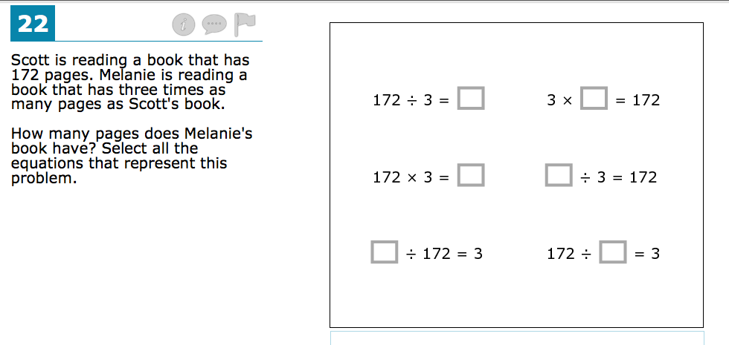
In this problem, students are asked to choose all equations that represent the problem, which requires students to both understand and interpret the relationship between multiplication and division in the context of a word problem. Past assessments have often tried to assess multiplication and division as separate skills, while the Smarter Balanced assessments will highlight the relationship between the operations to support the knowledge and skills that students need for later study of algebra.

Mathematics – Technology-Enhanced Item (High School)
This high school item has many noteworthy features. First, it attends to the coherence of the standards by drawing on content across multiple grade levels to illustrate that problem solving often requires students to know which tools and knowledge to draw upon in responding to a question. We have a long history in math classrooms of giving students problems to solve that align to “this chapter,” which takes away most of the challenge associated with good problem solving. This sample item allows students to make a decision about how much water is moved from Tank A to Tank B to solve the problem. Some students may decide to move only a little bit of water and others may decide to empty Tank A. Neither strategy is right or wrong, but both are available and represent one of the nice features of an online assessment: Students have to interact with the assessment item as part of the solution strategy.
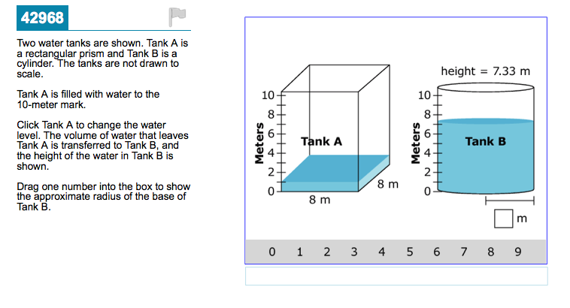
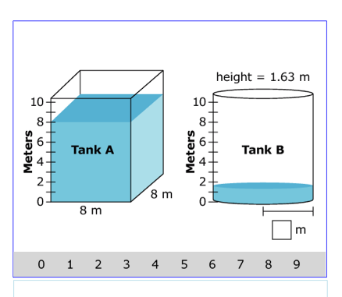

English Language Arts/Literacy – Multiple Choice Item (Grade 7)
The Common Core State Standards emphasize the use of gathering evidence from credible sources. This English language arts/literacy item is a research item that asks students to use reasoning and evaluation to assess the credibility of sources in order to select relevant information for a proposed report. The item was developed to mirror an authentic research process. The students are first given a research plan and results from an Internet search and then asked to choose which source would most likely have creditable and relevant information. The answer is “C.”

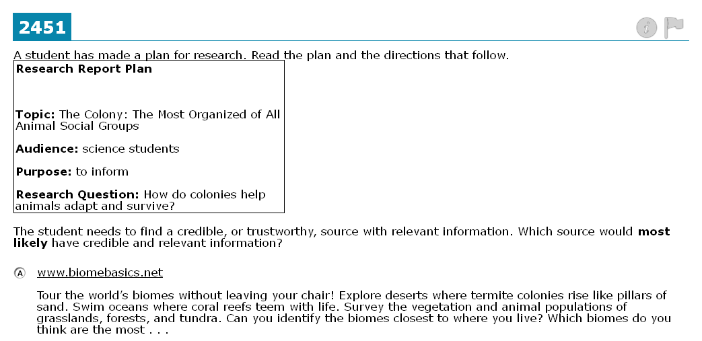
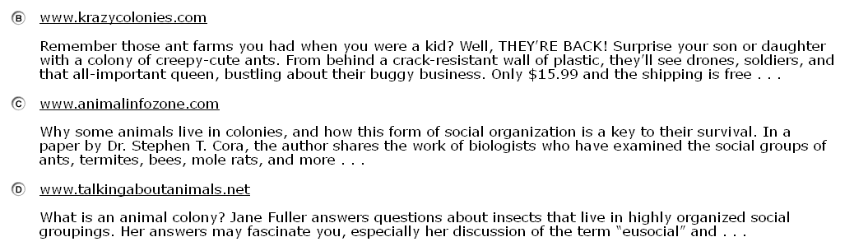

Score | Rationale | Exemplar
2 | The response:  - provides adequate reasoning and relevant evidence from the student notes supporting the claim  - adequately addresses (or develops) counterargument using adequate reasoning and/or evidence (note: only relevant if question calls for this)  - adequately elaborates reasoning and evidence using precise words/language | That amendment guarantees “the right of people to be secure in their persons...against unreasonable searches.” In interpreting this amendment, the United States Supreme Court has ruled that police must obtain a warrant from a judge before tracking a suspected drug trafficker using GPS. If it is illegal to track someone suspected of a felony without a warrant, opponents to the board's EID plan may argue, how can it be legal to track a student who may be guilty of nothing more than staying in bed with a cold? But the Supreme Court also has ruled that Fourth Amendment rights do not apply to students in schools in the same way as they apply to adults. According to recent Court rulings, schools have a responsibility to maintain order in the “special situation” of public schools, and this overrides students’ privacy rights. Opponents of EIDs also may argue that their use undermines trust. Being suspicious about “Big Brother watching” is understandable; however, these objections will diminish over time.  Annotation: This response uses appropriate evidence from the student notes to address (rebut) the counterargument. While other “2” responses could have used different evidence from the notes to support the major claim, this response connects and elaborates the evidence chosen (e.g., “rights do not apply to students in schools in the same way as they apply to adults”) using well-chosen language to undermine the opposing point of view (“overrides,” “undermines”). Note that other “2” responses may organize the paragraph by just addressing counter argument without rebuttal.
1 | The response:  - provides general reasoning and general and/or limited and/or listed evidence supporting the claim from the student notes. The reasoning and evidence may be weakly integrated, imprecise, repetitive, vague, and/or copied or loosely related to the claim.  - partially addresses (or develops) counterarguments using general and/or limited and/or listed evidence supporting the counterargument(s) (if question calls for this)  - partially elaborates reasoning and evidence using general words/language | That amendment says people have a right against unreasonable searches. The Supreme Court has said that cops can't use GPS to track criminals, how can it be right to use it to track kids who aren't doing anything wrong? Also, EIDs will make students not trust their teachers if they think they're always being watched.  Annotation: While this response does reference some appropriate information from the student notes, the evidence and elaboration do not adequately address (analyze or rebut) the opposing point of view. The response also overstates causal relationships (e.g., EIDs making students mistrust teachers), and the language is too general (“cops,” “aren’t doing anything wrong”) to advance the argument. While other responses that earn a “1” may have different strengths/weaknesses, the “1” responses will be overall partial or limited.
0 | The response:  - provides reasoning and evidence supporting the claim from the student notes that is minimal, irrelevant, absent, incorrectly used, or predominately copied and may interfere with the meaning of the text  - provides a weak or no attempt to address (or develop) counterargument(s). Reasoning and evidence supporting the arguments is minimal, irrelevant, absent, incorrectly used, or predominately copied and may interfere with the meaning of the text (if question calls for this)  - includes no elaboration of reasoning and evidence or, if present, primarily uses inappropriate or vague words/language | But everyone knows it's not right to spy on people. The Constitution says so.  Annotation: This response makes very weak reference to student notes (“Constitution”). The only attempt to address counterargument is an assumption based on “everyone knows…,” and relies on vague language (“it’s not right”) does not advance the argument.

